LAB 11
Exercise 1
File: SingletonFactoryDemo.java

Exercise 2
File: StrategyObserverDemo.java

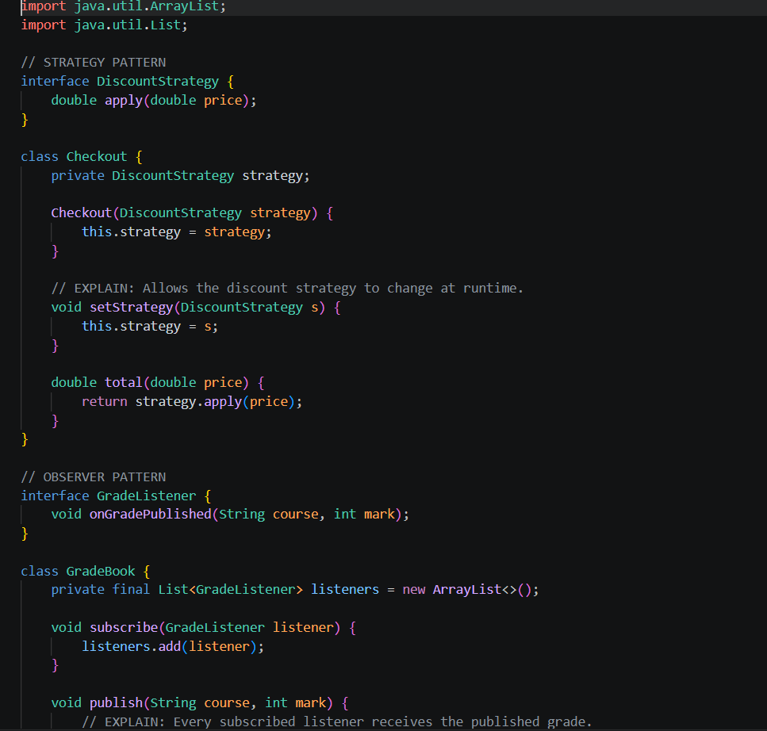
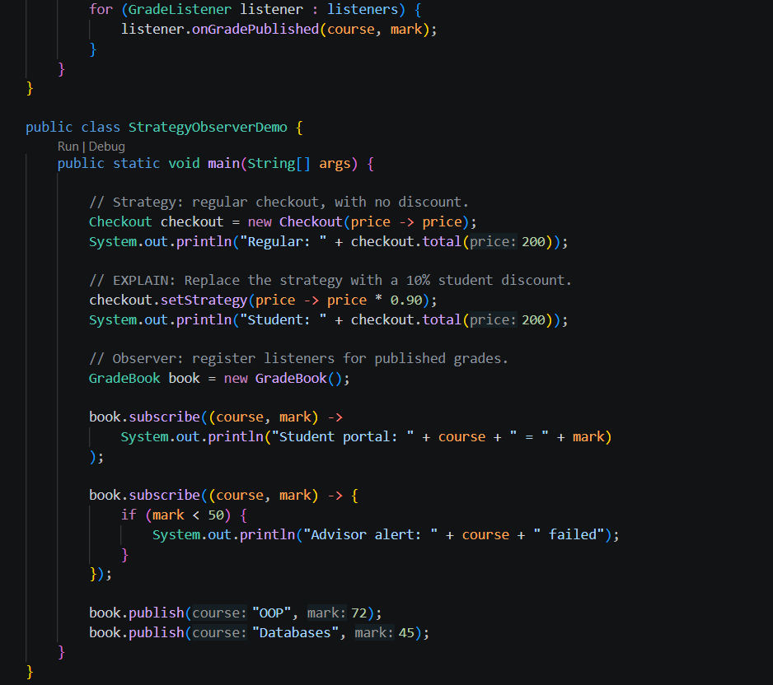
Output
